Space Shuttle thermal protection system

The Space Shuttle thermal protection system (TPS) is the barrier that protects the Space Shuttle Orbiter during the searing 1650 °C (3000 °F) heat of atmospheric reentry. A secondary goal is to protect from the heat and cold of space while on orbit.^{[1]} The TPS covers essentially the entire orbiter surface, and consists of seven different materials in varying locations based on amount of required heat protection:
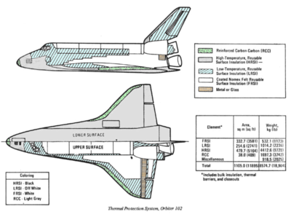
Thermal Protection System Constituent Materials, Space Shuttle Columbia (OV-102)
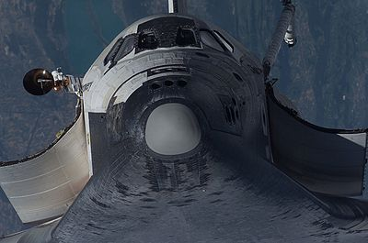

- Reinforced carbon-carbon (RCC), used in the nose cap and wing leading edges. Used where reentry temperature exceeds 1260 °C (2300 °F).
- High-temperature reusable surface insulation (HRSI) tiles, used on the orbiter underside. Made of coated LI-900 Silica ceramics. Used where reentry temperature is below 1260 °C.
- Fibrous refractory composite insulation (FRCI) tiles, used to provide improved strength, durability, resistance to coating cracking and weight reduction. Some HRSI tiles were replaced by this type.
- Flexible Insulation Blankets (FIB), a quilted, flexible blanket-like surface insulation. Used where reentry temperature is below 649 °C (1200 °F).
- Low-temperature Reusable Surface Insulation (LRSI) tiles, formerly used on the upper fuselage, but now mostly replaced by FIB. Used in temperature ranges roughly similar to FIB.
- Toughened unipiece fibrous insulation (TUFI) tiles, a stronger, tougher tile which came into use in 1996. Used in high and low temperature areas.
- Felt reusable surface insulation (FRSI). White Nomex felt blankets on the upper payload bay doors, portions of the midfuselage and aft fuselage sides, portions of the upper wing surface and a portion of the OMS/RCS pods. Used where temperatures stay below 371 °C (700 °F).
Each type of TPS has specific heat protection, impact resistance, and weight characteristics, which determine the locations where it is used and the amount used.
The shuttle TPS has three key characteristics that distinguish it from the TPS used on previous spacecraft:
- Reusable. Previous spacecraft generally used ablative heat shields which burned off during reentry and so couldn't be reused. This insulation was robust and reliable, and the single-use nature was appropriate for a single-use vehicle. By contrast, the reusable shuttle required a reusable thermal protection system.
- Lightweight. Previous ablative heat shields were very heavy. For example the ablative heat shield on the Apollo Command Modulecomprised about 1/3 of the vehicle weight. The winged shuttle had much more surface area than previous spacecraft, so a lightweight TPS was crucial.
- Fragile. The only known technology in the early 1970s with the required thermal and weight characteristics was also so fragile, due to the very low density, that one could easily crush a TPS tile by hand.

